|  |  |  |  |
| --- | --- | --- | --- |
| **SVKM's-IOT, Dhule**Shri Vile Parle Kelavani Mandal's  **INSTITUTE OF TECHNOLOGY**  **DHULE (M.S.)**  **DEPARMENT OF COMPUTER ENGINEERING** | | | |
| **Subject :** Java Programming Lab (Seminar-I) | | | Remark |
| **Name :**  Ansari Asharul Ameen Naeem Ahmad | | **Roll No. :** 63 |
| **Class:** SY. Comp. Engg. | **Batch : S4** | **Division: A** |
| **Expt. No. :**03 | **Date : 26/08/2024** | | Signature |
| **Title** : Write Java Programs to demonstrate: Arithmetic Promotion | | |
|  | | |
|  | | |

**// program 1**:

implicit type casting

import java.util.Scanner ;

class casting {

public static void main(String[]args){

Scanner obj = new Scanner (System.in);

System.out.println("enter the integer value");

int x = obj.nextInt();

long l;

l=x;

System.out.println("l="+l);

}

}

// output :

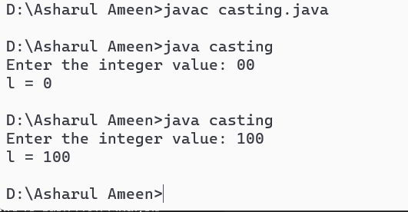

**// program 2:** explicit type casting

import java.util.Scanner;

class explicit {

public static void main(String[]args){

Scanner obj = new Scanner (System.in);

double l;

System.out.println("enter the value for double");

l=obj.nextDouble();

int x;

x=(int)l;

System.out.println("int ="+x);

}

}

//output :

